ortho/z-space software: highly accurate orthorectification
of very high resolution satellite images

Victor V. Nekrassov, Prof. Vladimir F. Chekalin, Nikolai M. Moltchachkine

Sovinformsputnik, 47, Leningradskiy Pr., 125167 Moscow, Russia
phone: (7-095)-943-17-82
fax: (7-095)-943-05-85
e-mail: nick@sovinformsputnik.com

KEY WORDS: Software, Orthorectification, Accuracy, High resolution Imagery, DEM, GPS

ABSTRACT:

The growing offer on the world market of high and very high resolution (VHR) satellite images required adequate means for their processing with the aim of extraction of the most accurate and valuable information from them. The paper considers the issues of orthorectification of the modern VHR satellite images. There are considered sensor models providing very high accuracy of orthorectification and their implementation in Russian Ortho/Z-space photogrammetric software package. High accuracy orthorectification requires adequately accurate DEMs – the paper describes how they are derived from Russian TK-350 topographic satellite images using Ortho/Z-space software. In conclusion there are described the accuracy levels of orthorectification of VHR satellite images by Ortho/Z-space software obtained using different sources of geodetic data (GPS, navigation data, etc.).

1. INTRODUCTION

The growing offer on the world market of high and very high resolution (VHR) satellite images requires adequate means for their processing with the aim of extraction of the most accurate and valuable information from them. Very high image resolution (~1m) together with highly accurate field measurements of Ground Control Points (GCPs) using differential GPS equipment and appropriate image processing and photogrammetric software can ensure obtaining final product of high quality and accuracy. On the other hand, there are many hardly accessible areas on the Earth where field survey is difficult or even impossible. For such areas satellite navigation data and techniques of their effective use are of great importance.

2. PHOTOGRAMMETRIC PROCESSING OF VHR SATELLITE IMAGES

2.1 Processing with field survey data (GPS)

For accurate photogrammetric processing of VHR images it is necessary to have the following data:
- Plane-height basis (GCPs) with the accuracy not worse than 1-2m.
- Images with shooting angles not larger than 15-20 degrees.
- Digital Elevation Model (DEM) with the accuracy not worse than RMS = 5-7m.

Availability of such materials allows production of high resolution orthoimages with the accuracy not worse than RMS = 2-3m.

Development and wide use of navigation systems (GPS, GLONASS) allows obtaining of ground control points with the required and even better accuracy. Very high resolution (1-2 m) images are available on the market from Russian satellite systems, IKONOS satellite, and some others.

In case of availability of GPS control points Russian photogrammetric software system Ortho/Z-space described below is capable to produce DEM with the accuracy not worse than 5-7m from TK-350 images. For 10m ground resolution of TK-350 image the use of subpixel methods of correlation implemented in Z-space subsystem provides obtaining of DEM with required accuracy.

For production of orthoimages with high accuracy there is used a universal model of panoramic camera (Chekalin, 2000) implemented in Orthospace subsystem:

X = X_{s}+${\overset{·}{X}}_{s}+$( Z - Z_{s} - ${\overset{·}{Z}}_{s}$) ${\frac{X}{Z^{'}}}^{'};$ (1)
Y = Y_{s} + ${\overset{·}{Y}}_{s}+$ ( Z - Z_{s} - ${\overset{·}{Z}}_{s}$) ${\frac{Y}{Z^{'}}}^{'};$
$\overset{·}{X_{s}}=\overset{·}{V_{x}}⋅Dt;$ $\overset{·}{Y_{s}}=\overset{·}{V_{y}}⋅Dt;$ ${\overset{·}{Z}}_{s}=\overset{·}{V_{z}}⋅Dt;$ $\left(\begin{matrix}X^{'} \\ Y^{'} \\ Z^{'}\end{matrix}\right)=P\overset{·}{P}\left(\begin{matrix}x−x_{0} \\ y−y_{0} \\ −f\end{matrix}\right);$
$\overset{·}{α}=\overset{·}{V_{α}}⋅Dt;$ $\overset{·}{w}={\overset{·}{V}}_{w}⋅Dt;$ $\overset{·}{c}={\overset{·}{V}}_{c}⋅Dt;$

It includes 6 static and 6 dynamic parameters. The static parameters describe the standard model of a frame (aerial) image Other parameters take into account the influence of the dynamics of the real process of the formation of the image at the scanning of the terrain. The necessity of the dynamic model is determined by the peculiarities of the geometry of the panoramic and scanner images.

The accuracy of image orientation achieves the level of 1 pixel of source image thus providing the required high accuracy of image orientation and orthorectification for VHR images. For acquisition angles of 15-20 degrees and DEM accuracy of RMS = 5-7m the resulting orthoimage will be obtained with the accuracy not worse than RMS = 2-3m. Such orthoimage can be used as a part of a digital GIS, directly as an orthoimage layer and serve as a basis for production of various vector layers.

2.2. Processing of images of non-accessible territories

One of the important tasks of modern cartography still is mapping of non-accessible territories. It could seem that in the modern time of developed transportation, communications and navigation means (such as GPS or GLONASS) there remained no territories non-accessible for direct mapping. However, due to political, military or other restrictions there are still many “white spots” on the map of the world. For solving of this task the use of Russian satellite system “Kometa” seems to be very attractive.

System “Kometa” provides both high resolution (2m) images taken by KVR-1000 camera and stereo coverage of the same territory with medium resolution (10m) taken by TK-350 camera. Further processing of TK-350 stereopairs together with onboard navigation data provides obtaining of plane-height basis for practically any area of the earth ground with the accuracy not worse than 15-20 m and sometimes with the accuracy of 12-15m. Such data provide obtaining of Digital Elevation Models (DEM) with the accuracy of 10 – 15 m.

High resolution (2m) images are orthorectified using previously obtained DEM. As a result one can produce orthoimages with the accuracy of absolute referencing of 10-15m and higher internal accuracy of 5-7m.

For production of DEM from medium resolution images and orthoimages from high resolution images software package Ortho/Z-space is successfully used.

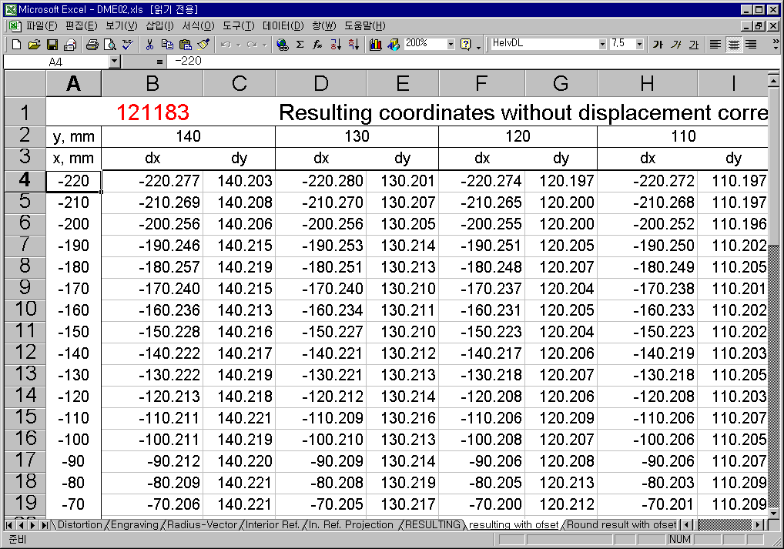3. PHOTOGRAMMETRIC PROCESSES PERFORMED WITH ORTHO/Z-SPACE SOFTWARE

Digital photogrammetric desktop system Ortho/Z-space is developed by Sovinformsputnik, Moscow, Russia in cooperation with some partner companies. It implements the Russian concept of photogrammetric processing of satellite and aerial images. The system is used for digital processing of satellite images TK-350, KVR-1000, KFA-1000, MK-4, Landsat TM and IKONOS as well as panoramic and frame aerial images.

Ortho/Z-space software provides production and editing of orthoimages, digital elevation models as well as generation of basic components of composite images. The system is useful to process small areas as well as to fulfill large projects. Digital photogrammetric system Ortho/Z-space is IBM PC-compatible and consists of 2 sub-systems:
- Orthospace,
- Z-space.

3.1. Production of Digital Elevation Model (DEM) using Z-Space software

Z-SPACE is developed for automatic creation, editing and stitching of DEM from stereo images. The size of images being processed is limited only by volume of hard disk. To accelerate processing pyramids of images are used. The system provides high speed of DEM creation in the automatic mode.

For production of DEM Z-Space can use stereo images of TK-350 (main purpose), MK-4 and aerial photography. At present time the system is tested with SPOT stereo images.

Production of accurate DEM requires adequate plane-height basis. Depending on the required accuracy of DEM it is possible to use plane-height basis obtained from the following sources:
- Russian photogrammetric networks. Typical DEM accuracy is 10 – 15 m;
- Russian photogrammetric networks with additional GPS points provided by the customer. Typical DEM accuracy is 7 – 10 m;
- GPS points only. Typical DEM accuracy is 5 – 7 m.

Z-space system can use plane-height basis both in the form of GCPs and in the form of parameters of exterior orientation of images which increases accuracy of processing of images.

The technological scheme of DEM production for customer's selected map projection and/or given spheroid is the following:
- Recalculation of GCP coordinates from customer's system to coordinate system SK-42 (spheroid Krasovsky, projection Gauss-Krueger).
- Production of DEM in coordinate system SK-42.
- Reprojection of obtained DEM to customer's coordinate system.

For implementation of these technological line the following utilities are used:
- Coordinate calculator for recalculation of GCPs.
- Reproject utility for reprojection of DEMs or raster images.
These utilities are parts of Orthospace system.

The following main processes are performed during DEM production:

Figure 1. TK-350 image distortion table

Interior orientation of stereopair images includes automatic search for control crosses (for TK-350 images) for input of the distortion table (see Figure 1), which takes into account corrections for engraving of control crosses, distortion of the camera lens, internal refraction of light beams and shift of photo-sensitive material;

Relative orientation of stereopair images has options of manual and automatic (using correlator) location of points;

Exterior orientation of stereopair images has options of manual and automatic location of points. It is possible to input (import) the elements of exterior orientation;

Transformation of stereopair images in the basic plane by rotation along the basis line (epipolar rotation);

Creation of DEM over the required rectangular area in the form of a regular net of height values with the use of subpixel methods of correlation;

Automatic correction of DEM using orthoimage with subsequent filtering (6 possible methods) applicable for all DEM or for its specified part (see Figure 2);
Figure 2. Automatic correction of DEM – area editing
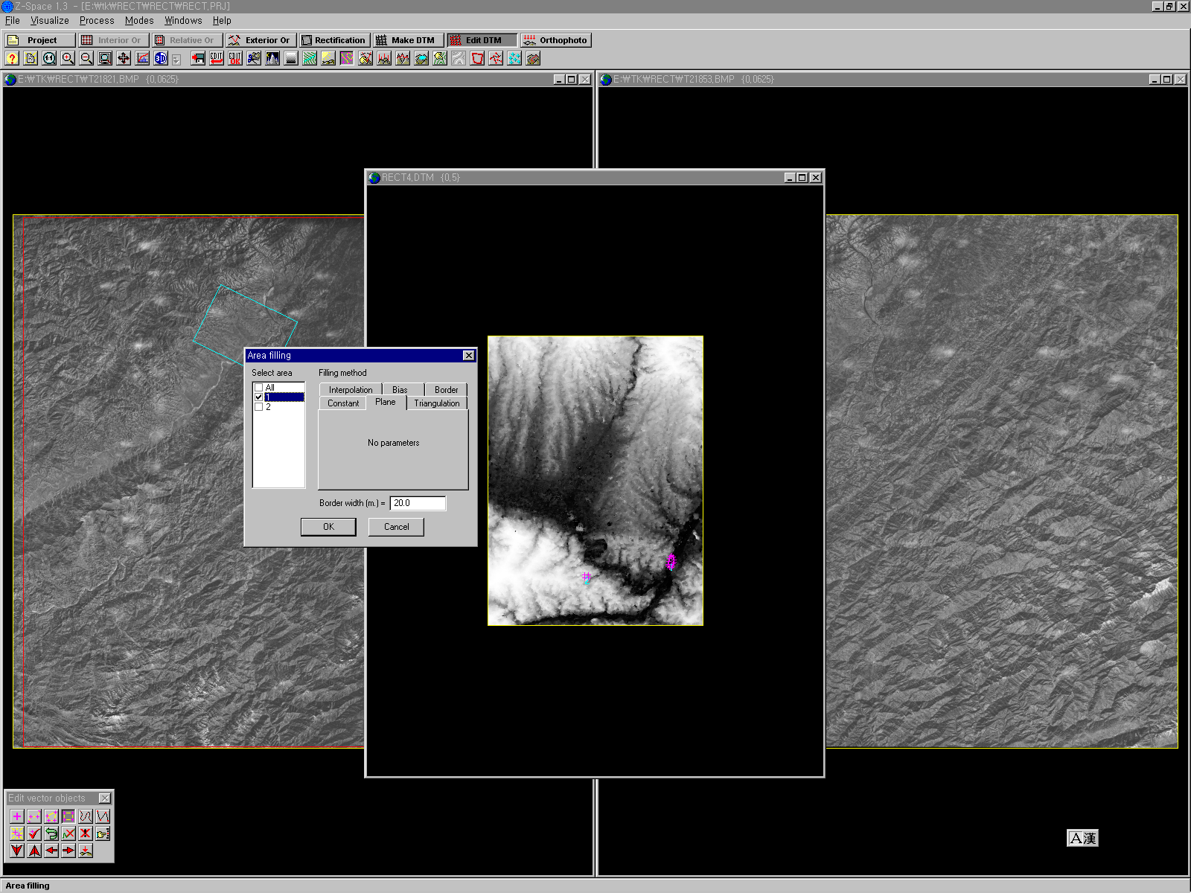
DEM editing by operator with creation of vector objects (pickets, polygons, polylines) in a stereo mode by an operator;

Stitching of DEMs produced from one stereopair or different stereopairs;

Export of resulting DEM to binary, ASCII or vector formats.

3.2. Orthorectification using Orthospace software

Orthospace software performs exterior orientation of an image in two modes: as central projection (frame) and panoramic projection (static or dynamic). In the latter case a satellite image dynamic model is used. All necessary calculations are made on Krasovsky or WGS-84 ellipsoid. The mathematical model of solving the task of external orientation in Orthospace software uses a topocentric coordinate system, which provides the maximum accuracy of the solution for satellite images. The accuracy of the image processing achieved on this basis is 1-2 image pixels.

The software performs one of the following transformations of source image: geometric correction based on projective transformation or orthorectification. From the mathematical point of view geometric correction is a simplified process of orthorectification performed with the use of the mean terrain altitude of the area to be processed. The process of orthorectification is always performed with the use of DEM. In the process of production of an orthoimage corrections are introduced with account taken of the influence of terrain relief, Earth curvature, image inclination angles, movement of the satellite, Earth rotation, movement of the moving parts of the camera.

The following image geometry models are implemented in Orthospace:
  - affine transformation (6 parameters);
  - polynomial (2nd and 3rd order);
  - frame image (6 parameters);
  - static panoramic model (6 parameters);
  - dynamic panoramic model (12 parameters).

The most universal model is dynamic panoramic one providing maximal accuracy in most applications. However for transformation of images of central projection cameras the frame image model can be successfully used. Affine model is used to prepare a map for further selection of GCPs.

3.3. Geodetic calculations

Calculator GeoSpace provides recalculations of sets of points coordinates in more than 200 combinations of local ellipsoids, coordinate systems and datums. The following cartographic projections can be used: UTM, Transverse Mercator, Lambert and stereographic. Input data can be specified as geodetic coordinates B, L, H or rectangular coordinates x, y in the selected map projection. The heights of points can be counted from the level surface of either input or output ellipsoid.

Reproject utility is used to re-project orthoimage to the required coordinate system, local ellipsoid and datum.

4. CONCLUSION

The resulting accuracy of an orthoimage depends on the accuracy of geodetic basis, accuracy of DEM, and image resolution. The practical use of Ortho/Z-Space software showed that for non-accessible territories the accuracy of orthorectification of VHR images is determined by the accuracy of geodetic basis and is 10-15v using geodetic basis obtained from navigation data of Russian Kometa system. In case of use of decimeter DGPS field measurements the accuracy of orthorectification of VHR images is determined by image resolution and equals 1-2 image pixels. This means that for KVR-1000 (2m) the accuracy is 3-4 m, for IKONOS (1m) the accuracy is 1-2 m. For new satellite images with sub-meter resolution it is potentially possible to achieve the accuracy of better than 1m.

REFERENCES

1. V. F. Chekaline, M. M .Fomtchenko, Russian concept of the space images digital processing. ISPRS, Vol. XXXIII, Amsterdam, 2000

